
ATAR Biology

Unit 1: Topic 3
Week 10 – Population & Carrying Capacity



Student Study Notes

Unit Content
- The dynamic nature of populations influence population size, density, composition and distribution.
- Ecosystems have carrying capacities that limit the number of organisms (within populations) they support and can be impacted by changes to abiotic and biotic factors, including climatic events.
Populations
Living things of the same species often exist together in groups or populations. Population size and distribution can be affected by other populations and abiotic features.
In this topic, you will look at how populations are studied and factor that can affect the size of a population and its distribution.

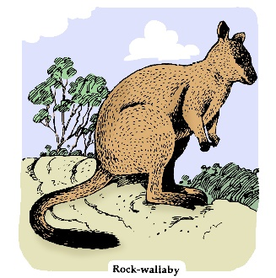©Westone

Upcoming Assessment: Task 4 Science Inquiry - Populations
In a study of populations, it is important to determine the size and distribution of organisms. You will complete an inquiry assessment task, demonstrating your understanding of population dynamics.

Causes of population change
Depending on the density of a population, factors such as relationships vary in their effect.
- Density dependent factors
- Density independent factors

Factors that affect a population as it increases in size are density dependent. Competition for available resources causes change in dense populations. A high population density usually results in overcrowding, with too many individuals competing for resources such as food and water. Disease and parasites are density dependent factors that affect population size.

Factors which are unaffected by a population’s density are considered density independent. Examples include drought, temperature or fire. Any factor that causes change to a population, regardless of its density is density independent. Natural disasters are a good example as a flood or violent storm will usually kill individuals from small or large populations.

Density
Population density is defined as the number of individuals per unit area. We can calculate
population density using the formula below.

Density = number of a particular species ÷ total area sampled

Knowing a population’s density is useful when studying a population in its natural habitat.

Distribution
Distribution is the geographic extent or spread of a particular species. Distribution depends on several factors such as environmental conditions, (soil type) and relationships with other organisms (predator/prey).

Population growth activity
A population grows in size under ideal conditions and models can be used to predict what could happen to a real population over time. An example is provided below.
Under ideal conditions, bacteria reproduce by binary fission every 20 minutes.
In the model below, if each individual divides to produce two offspring, the population will double with each generation. Starting at time zero, with a single bacterium, 10 generations will produce 1024 individuals after 200 minutes, as shown below.
Generation | 0 | 1 | 2 | 3 | 4 | 5 | 6 | 7 | 8 | 9 | 10
Total per generation | 1 | 2 | 4 | 8 | 16 | 32 | 64 | 128 | 256 | 512 | 1024

Plot the data as a graph using the grid below.

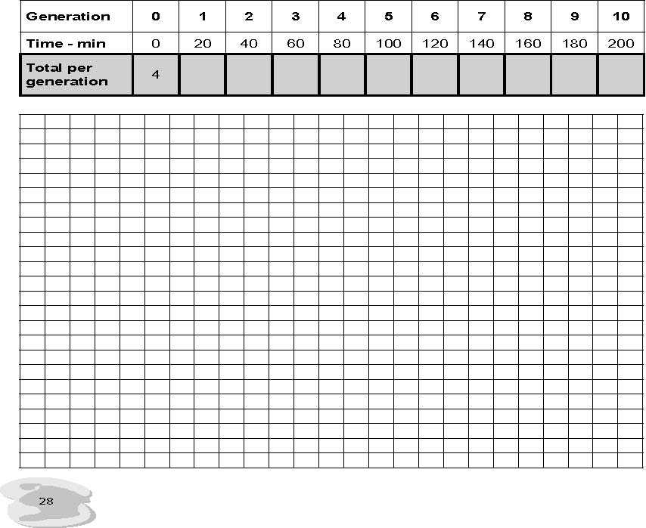
Bacterial population growth

Exponential growth
Your graph of the bacterial growth model data should have a ‘J-shaped’ curve as shown below.
Population growth against time under ideal conditions
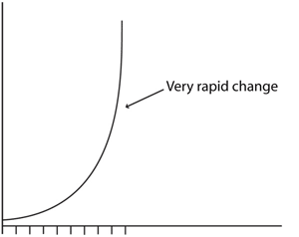

The curve is gradual at first and then accelerates as the population doubles with time. This unlimited growth pattern is called exponential growth and assumes there are not any restraints on population growth. All populations are capable of exponential growth; however, the size of a population is limited by many factors.

Limits on population growth
A model population, such as bacteria grown under ideal conditions, does not always take into account factors that may limit growth in a population. The growth curve would take on a different shape if all the factors which affect a population came into effect.

Some of the factors affecting the growth of a population are listed below.

Biotic factors | Abiotic factors
Competition  Predation  Parasites  Disease  Food  Availability  Faecal matter | Weather and climate  Habitat disruption  Light  Soil  Temperature

Carrying Capacity
For any given population, the maximum number of individuals that the environment can sustain is called the carrying capacity. As the carrying capacity is reached, the number of births equals the number of deaths and a growth curve takes on an S-shape (sigmoidal) as shown below.

Population growth against time under limited conditions
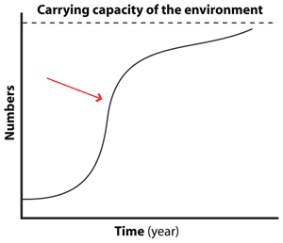
Questions
- In terms of growth rate, what does the arrow point to?

- Under what conditions would a population growth curve follow exponential growth?

- What limits population growth to a certain level? In other words, why do S-shaped curves of population growth exist?

PRACTICE QUESTIONS:
Source: AQA A-Level Biology Jan 2103
The diagram below shows an age population pyramid for humans in a country
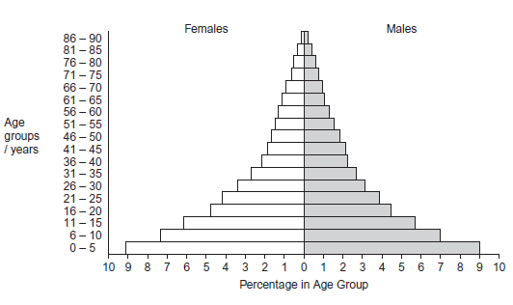
1. This country is in the early stage of a demographic transition. Describe the evidence for this.

Questions 2 and 3 refer to information below
The full line in each of the graphs a-b represents the changes in the density of a population of organisms with time. The broken line represents either:
- changes in density of another population, or
- changes in some environmental factor.
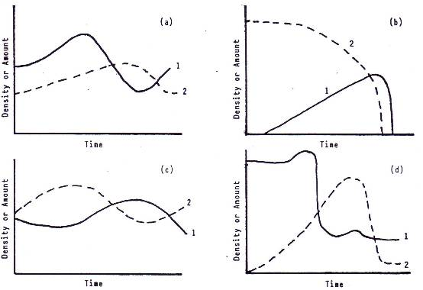

Select which graph best represents each of the situations described below.
2. Population (1) is held in check by a population of predators (2).
- Graph (a)
- Graph (b)
- Graph (c)
- Graph (d)

3. Population (1) is growing in a closed container with limited food supply (2).
- Graph (a)
- Graph (b)
- Graph (c)
- Graph (d)

A fish biologist is keen to ensure the gender and age distribution of a population is optimal to maximise breeding. In doing this, the biologist is interested in population:

- distribution
- composition
- size
- density

4. The following question relates to the information provided below.
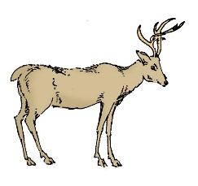
In 1905 a population of mule deer (Odocoileus hemionus) living in a reserve on the north side of the Grand Canyon, in the western United States were preyed on by wolves, mountain lions and humans during the hunting season.
In 1907, with the idea of increasing the deer population, the reserve was closed to hunting, predator control was introduced and the numbers of predators were drastically reduced.
The deer population rose rapidly until 1925, then in two winters, 60% of the herd starved to death. The population continued to fall thereafter and with hunting of deer reinstated, the population numbered about 10,000 by 1960.
It is thought that there was very little change in the deer population due to migration.
The following data relates to the estimated number of deer in the reserve between 1906-1960.
Year | 1906 | 1924 | 1927 | 1932 | 1939 | 1954 | 1955 | 1957 | 1960
Estimated deer numbers | 4 000 | 100 000 | 28 000 | 14 000 | 10 000 | 27 000 | 11 000 | 12 000 | 10 000

Below is a graph of the data collected.
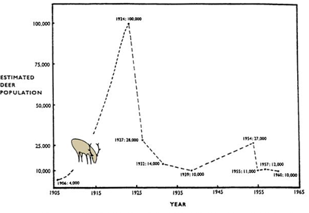
- List two reasons for the change in deer population between 1907 and 1924.

- Many biologists believe that the change in population from 1924 to 1927 was due, not to cold winter conditions, but to the high density of the deer population in the reserve. Explain their reasoning.

Predator control has continued beyond 1930, yet the numbers of deer continued to fall.
- Provide a hypothesis which offers an explanation for the continued decline in the deer population size.

- Based on the evidence obtained in this study, would you agree that predators are harmful to a natural population? Why or why not?

5. Stable ecosystems are most likely to

- be near the sea.
- be in water bodies.
- have a greater biodiversity.
- have a limited biodiversity.

Source: ExploreBiology.com

6. All of the following statements concerning characteristics of predator-prey relationships are correct EXCEPT:
- A rise in the population of prey is often followed by a rise in the population of predators.
- A rise in the population of predators is followed by a decrease in the population of prey.
- Camouflage is an adaptation that protects prey.
- The population of predators most often eliminates the population of prey.

7. Which point on the curve in the diagram above best represents the carrying capacity of the environment for the population shown.

- B
- C
- D
- E

Practice Extended Response
Source: WACE 2B exam 2014
8. There are many factors that determine the carrying capacity of an ecosystem. Define the term “carrying capacity” and discuss the density dependent and density independent factors that affect an ecosystem’s carrying capacity.

Population calculations

Organisms may leave a population by immigration or death. Organisms may enter a population by emigration or birth. Birth, death, immigration and emigration are the determiners of population density. A population’s overall change in numbers is provided by subtracting those that leave from those that arrive, as shown in the equation below.

(births + immigration) − (deaths + emigration)


The overall change converts into a rate of change (r) by including a period of time such as a year and using a standard number of individuals, usually one thousand. This is to enable comparisons between populations to be simplified and standardised.

r = (b + i) − (d + e)

The letters in the above equation represents:

(b) birth rate – the number born per 1000 per year
(d) death rate – the number dying per 1000 per year
(i) immigration rate – the number entering the population per 1000 per year
(e) emigration rate – the number leaving the population per 1000 per year.

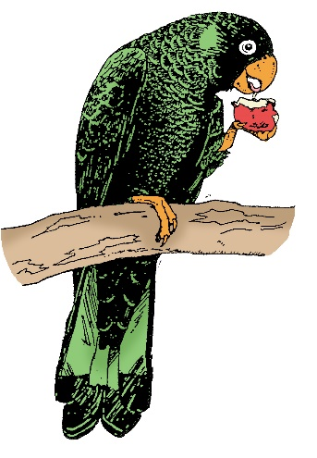
Population calculations - worked example
In one year, a population of 200 western rosellas, Platycercus icterotis, raised 100 chicks. During the same time, 10 birds moved into the area while 80 birds died and 5 left.
What is the overall change for this population?

Step 1: Calculate the overall change.

The overall change = (births + immigration) − (deaths + emigration)

= (100 + 10) − (80 + 5) = 25 birds were added to the population of 200.

What is the overall rate of change for this population?

Step 2: Calculate the overall rate of change and then convert it into a number (per thousand per year).

The rate of change for 200 birds is 25. (From Step 1)

The overall rate of change for this population is 125 birds per thousand per year.
Thus a population of 1000 birds will add an extra 125 birds to its population each year.

The overall rate of change for 1000 birds = 25 × 1 000 ÷ 200 = 125
Note:
- A positive value indicates the population is growing.
- A negative rate indicates the population is declining.

Population rate of change activity

Remember to show all steps in your working out.

- a) Calculate the overall change in a population of 4000 silver gulls, Larus novaehollandiae, where 1700 individuals died, 300 migrated out of the area, 600 moved in and 800 were born during the same year.

b) What was the overall rate of change of the gull population per thousand during the year?

c) Based on your calculations, is the gull population declining?

- During one year, 280 kangaroos were born into a population, 69 immigrated, 82 emigrated and 93 died. Calculate the overall change and show your calculation.

The following data relates to monthly estimates of numbers of mice in an abandoned barn, observed for seven consecutive months.

3. a) Draw a graph to show the population change of mice over the seven-month period on the grid provided and then answer the following questions.
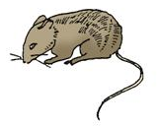
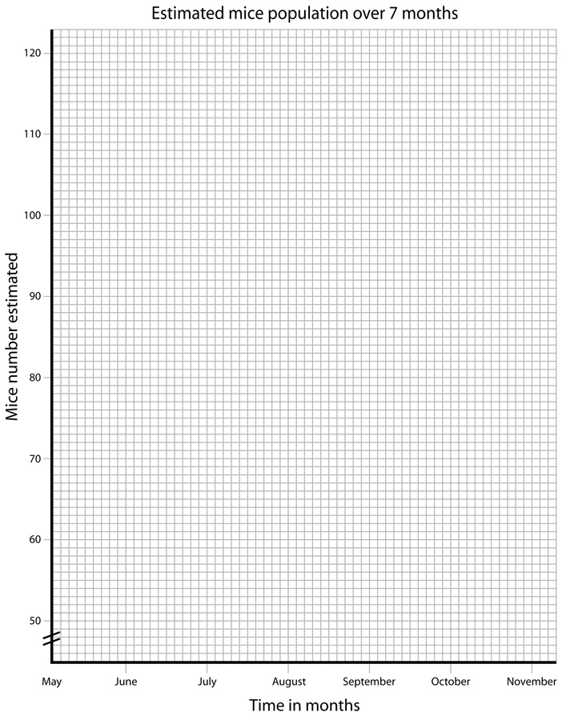
Month | May | June | July | Aug. | Sept. | Oct. | Nov.
Estimated mouse numbers | 50 | 75 | 105 | 70 | 95 | 120 | 115

b) What was the overall change to the mouse population during the period observed?

c) Between which two months was the rate of change of the population size greatest?

d) If 55 mice moved into the barn during the period observed; 20 emigrated and 25 mice died, how many mice were born? (Using the equation).

e) What would be the likely growth pattern of this population if all predators were destroyed before July and adequate food was available?

f) What would happen if the available water was drastically reduced early in the growth of the population? Graph your prediction using a dotted line on your original set of axes.

